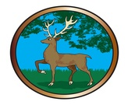BERKSHIRE OPEN SHOOT, DOUBLE DEWER

Sunday 26th September 2021

VENUE:

WORPLESDON RANGE, WORPLESDON, SURREY

GU3 3LB

PLEASE GIVE IT YOUR SUPPORT

C:\Users\Eric\AppData\Local\Microsoft\Windows\Temporary Internet Files\Content.IE5\67RU3S74\MC900411992[1].wmfC:\Users\Eric\AppData\Local\Microsoft\Windows\Temporary Internet Files\Content.IE5\67RU3S74\MC900411992[1].wmfBACON BAP, HOME MADE CAKES, PAVLOVA.

TEA AND COFFEE